# General

This document contains test data in support of the corresponding Recommended Practice and Technical Note.

# Contents

1 General 1

2 Contents 1

3 Equipment 3

3.1 Oscilloscope 1 and Probes 3

3.2 Oscilloscope 2 and Probes 3

3.3 Differential Probe 4

3.4 Current Probe 4

4 Test Circuitry 4

4.1 Decoder Transmitter 4

4.2 Booster Detector 5

4.3 Booster Repeater Transmitter 5

4.4 Command Station Detector 6

4.5 Additional Notes 6

5 Decoder Transmitter Verification 7

5.1 Verification of Decoder Transmitter Timing 7

6 Decoder Transmitter Placed at Booster (<1 Foot Track Bus) 8

6.1 Booster Detector Comparator Input (Zoomed Out) 8

6.2 Booster Detector Comparator Input 8

6.3 Booster Detector Comparator Output 9

6.4 Booster Repeater Digital Isolator Input 9

6.5 Booster Repeater Digital Isolator Output (Repeater Transmitter) 10

6.6 Command Station Detector Comparator Input (1 Foot Cat5e Cable) 10

6.7 Command Station Detector Comparator Output (1 Foot Cat5e Cable) 11

6.8 Command Station Detector Comparator Input (1000 Feet Cat5e Cable) 11

6.9 Command Station Detector Comparator Output (1000 Feet Cat5e Cable) 12

6.10 Command Station Detector Comparator Input (1000 Feet Cat5e Cable), 6x 500Ω half rectified (simulated) booster loads at end of 1000 feet LCC Cable 12

6.11 Command Station Detector Comparator Output (1000 Feet Cat5e Cable), 6x 500Ω half rectified (simulated) booster loads at end of 1000 feet LCC Cable 13

7 Decoder Transmitter at Booster (<1 Foot Track Bus) With 27pF at Comparator Input 14

7.1 Booster Detector Comparator Input (Zoomed Out) 14

7.2 Booster Detector Comparator Input 15

7.3 Booster Detector Comparator Output 15

7.4 Booster Repeater Digital Isolator Input 16

7.5 Booster Repeater Digital Isolator Output (Repeater Transmitter) 16

7.6 Command Station Detector Comparator Input (1 Foot Cat5e Cable) 17

7.7 Command Station Detector Comparator Output (1 Foot Cat5e Cable) 17

7.8 Command Station Detector Comparator Input (1000 Foot Cat5e Cable) 18

7.9 Command Station Detector Comparator Output (1000 Foot Cat5e Cable) 18

7.10 Command Station Detector Comparator Input (242 Foot Cat5e Cable) 19

7.11 Command Station Detector Comparator Output (242 Foot Cat5e Cable) 19

8 Decoder Transmitter Placed at End of 100m Track Bus, 500Ω Half Rectified Termination 20

8.1 Booster Detector Comparator Input (Zoomed Out) 20

8.2 Booster Detector Comparator Input 20

8.3 Booster Detector Comparator Output 21

8.4 Booster Repeater Digital Isolator Input 21

8.5 Booster Repeater Digital Isolator Output (Repeater Transmitter) 22

8.6 Command Station Detector Comparator Input (1 Foot Cat5e Cable) 22

8.7 Command Station Detector Comparator Output (1 Foot Cat5e Cable) 23

8.8 Command Station Detector Comparator Input (1000 Foot Cat5e Cable) 23

8.9 Command Station Detector Comparator Output (1000 Foot Cat5e Cable) 24

8.10 Command Station Detector Comparator Input (242 Foot Cat5e Cable) 24

8.11 Command Station Detector Comparator Output (242 Foot Cat5e Cable) 25

8.12 Track Voltage at Decoder Transmitter during Data Transmission 25

9 Decoder Transmitter at End of 100m Track Bus, 500Ω Half Rectified Termination With 27pF at Comparator Input 26

9.1 Booster Detector Comparator Input (Zoomed Out) 26

9.2 Booster Detector Comparator Input 27

9.3 Booster Detector Comparator Output 27

9.4 Booster Repeater Digital Isolator Input 28

9.5 Booster Repeater Digital Isolator Output (Repeater Transmitter) 28

9.6 Command Station Detector Comparator Input (1 Foot Cat5e Cable) 29

9.7 Command Station Detector Comparator Output (1 Foot Cat5e Cable) 29

9.8 Command Station Detector Comparator Input (1000 Foot Cat5e Cable) 30

9.9 Command Station Detector Comparator Output (1000 Foot Cat5e Cable) 30

9.10 Command Station Detector Comparator Input (242 Foot Cat5e Cable) 31

9.11 Command Station Detector Comparator Output (242 Foot Cat5e Cable) 31

10 Decoder Transmitter Placed at End of 100m Track Bus, No Termination 32

10.1 Booster Detector Comparator Input (Zoomed Out) 32

10.2 Booster Detector Comparator Input 32

10.3 Booster Detector Comparator Output 33

10.4 Booster Digital Isolator Input 33

10.5 Booster Digital Isolator Output (Repeater Transmitter) 34

10.6 Command Station Detector Comparator Input (1 Foot Cat5e Cable) 34

10.7 Command Station Detector Comparator Output (1 Foot Cat5e Cable) 35

10.8 Command Station Detector Comparator Input (1000 Foot Cat5e Cable) 35

10.9 Command Station Detector Comparator Output (1000 Foot Cat5e Cable) 36

10.10 Track Voltage at Decoder Transmitter during Data Transmission 36

11 Decoder Transmitter Placed at End of 100m Track Bus, 110Ω Termination 37

11.1 Booster Detector Comparator Input (Zoomed Out) 37

11.2 Booster Detector Comparator Input 37

11.3 Booster Detector Comparator Output 38

11.4 Booster Digital Isolator Input 38

12 Booster Repeater Transmitter Voltage 39

12.1 Voltage at Booster Transmitter Output (Power Station Interface), 1000 Feed of Cat5e between Booster and Command Station 39

13 Transmitter Current at End of 100m Track Bus 40

13.1 No Termination 40

13.2 500Ω Half Rectified Termination 41

14 Document History 42

# Equipment

## Oscilloscope 1 and Probes

|  |  |
| --- | --- |
| Manufacturer | GW Instek |
| Model Number | GDS-2204E |
| Firmware Version | V1.41 |
| Probe Attenuation | 1:10 |
| Probe Input Resistance | 1MΩ |
| Probe Input Capacitance | 8.5pF~18.5pF |
| Probe Bandwidth | DC~300 MHz |

## Oscilloscope 2 and Probes

The date and time is not calibrated on this oscilloscope and should be ignored.

|  |  |
| --- | --- |
| Manufacturer | Tektronix |
| Model Number | TDS 460A |
| Firmware Version | Thu May 9 11:26:15 PDT 1996 |
| Probe Attenuation | 1:10 |
| Probe Input Resistance | 10MΩ |
| Probe Input Capacitance | 8.0pF |
| Probe Bandwidth | DC~500 MHz |

## Differential Probe

|  |  |
| --- | --- |
| Manufacturer | Micsig |
| Model Number | DP10013 |
| Probe Attenuation | 1:50 |
| Probe Input Impedance Differential | 10MΩ/1pF |
| Probe Input Impedance Single-Ended to Ground | 5MΩ/2pF |
| Probe Bandwidth | DC~100 MHz |

## Current Probe

|  |  |
| --- | --- |
| Manufacturer | Tektronix |
| Model Number | TCP202 |
| Minimum Sensitivity | 10 mA/div |
| DC Accuracy | ±3% |
| Probe Input Impedance Single-Ended to Ground | 5MΩ/2pF |
| Probe Bandwidth | DC~50 MHz |

# Test Circuitry

## Decoder Transmitter

VDD is 3.3V and R1 has been tuned to 18Ω resulting in a transmission current of ~30mA. Scope data is sampled at DATA_TX (MCU UART output) and at the TRACK_1/TRACK_2 terminals.

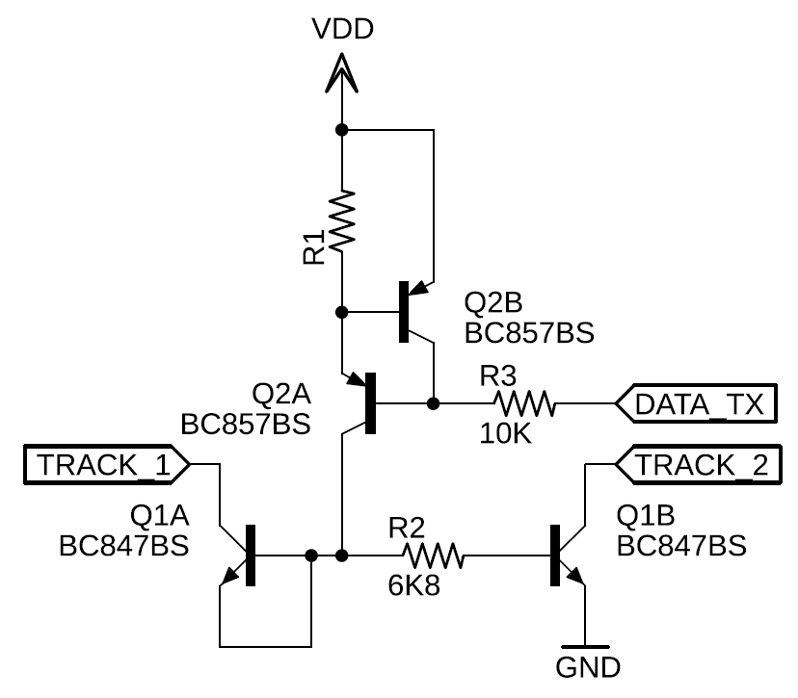

## Booster Detector

C2 and C3 are not populated for the majority of the captured data. In some cases, C2 and C3 are populated with 27pF, as noted in the relevant data capture sections. Scope data is sampled at IC1A [negative] comparator input and at IC1A comparator output.

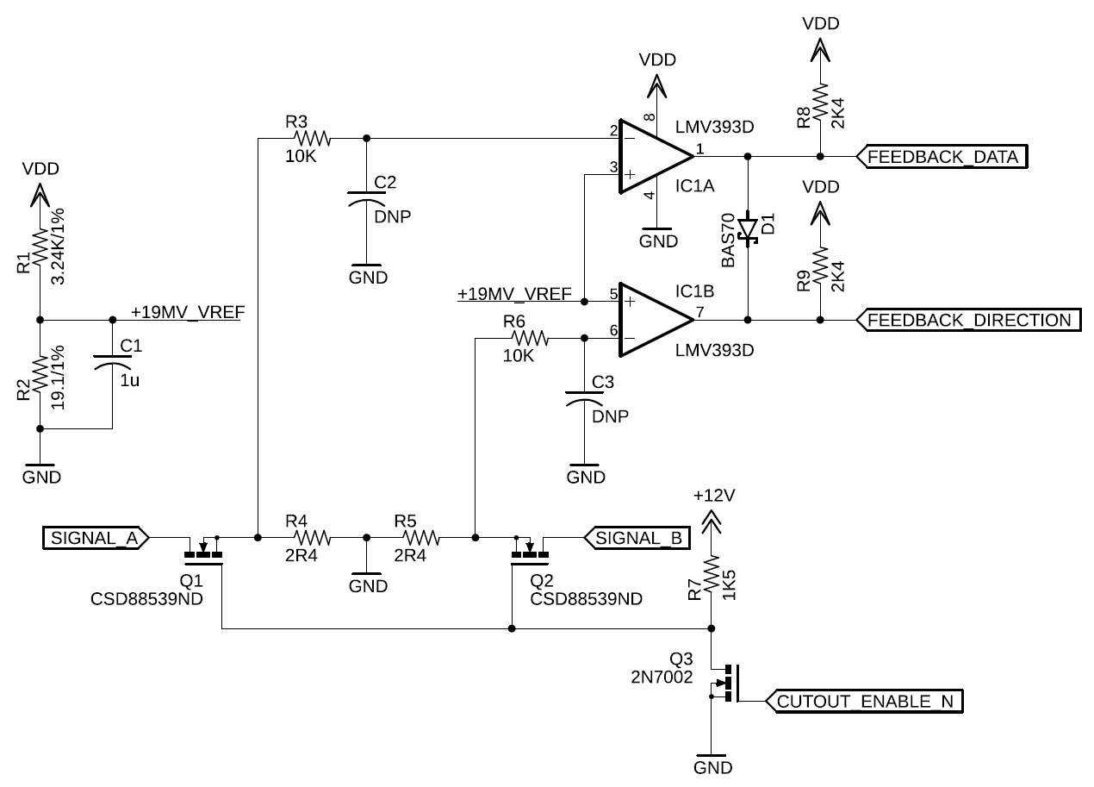

## Booster Repeater Transmitter

VDD is 5V and R1 has been tuned to 110Ω resulting in a transmission current of ~5mA. Scope data is sampled at DATA_TX (Digital Isolator Output) and at the TRACK_1/TRACK_2 terminals. In the context of the Booster Transmitter, TRACK_1/TRACK_2 represents the Power Station Interface terminals.



## Command Station Detector

C2 is not populated for the majority of the captured data. In some cases, C2 is populated with 27pF, as noted in the relevant data capture sections. Scope data is sampled at IC1A [negative] comparator input and at IC1A comparator output.

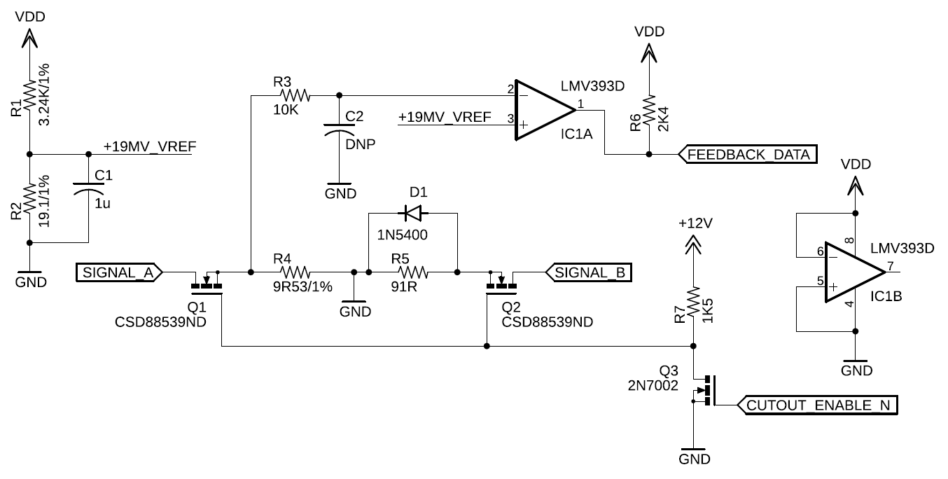

## Additional Notes

Between the booster detector comparator output and the booster repeater transmitter, there is some incidental push/pull CMOS digital logic and a Digital Isolator. The datasheets of these components have been verified to ensure that they do not introduce any measureable asymmetry in their propagation delays.

# Decoder Transmitter Verification

## Verification of Decoder Transmitter Timing

The following plot is taken at the decoder’s MCU UART output pin. This verifies that there is no measurable baud rate error starting from the decoder MCU transmitter.

* Channel 1: Transmitted data

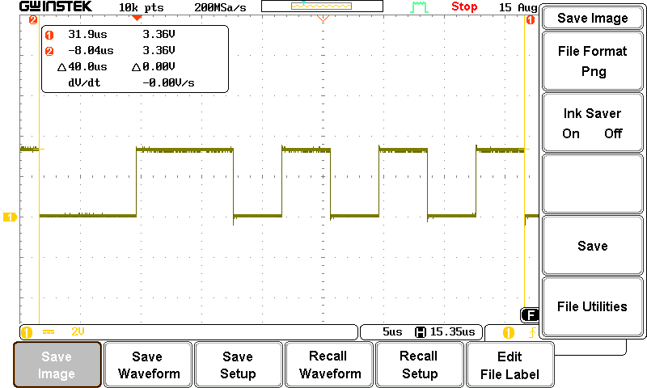

# Decoder Transmitter Placed at Booster (<1 Foot Track Bus)

## Booster Detector Comparator Input (Zoomed Out)

* Channel 1: Cutout enable (trigger)
* Channel 2: Received data

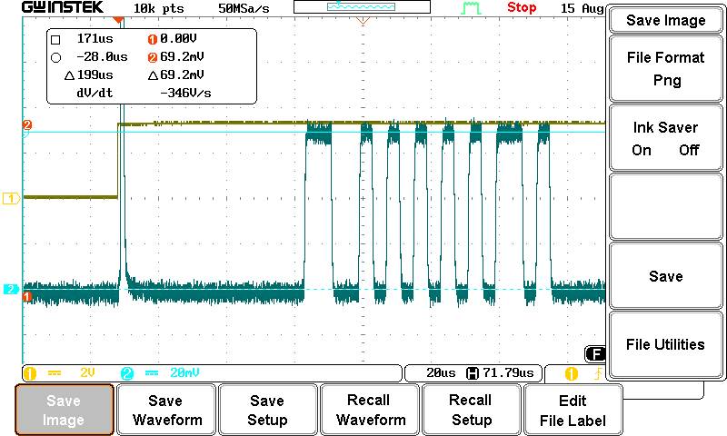

## Booster Detector Comparator Input

* Channel 1: Cutout enable (trigger)
* Channel 2: Received data

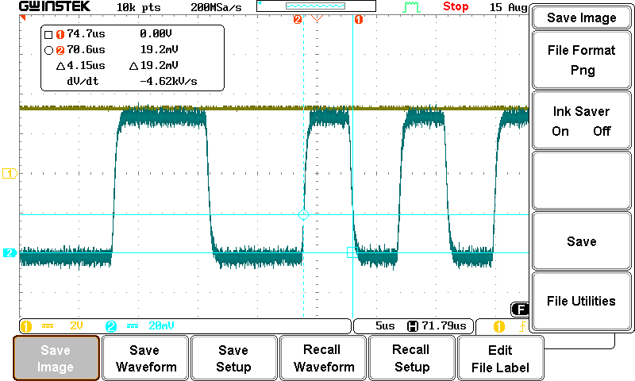

## Booster Detector Comparator Output

* Channel 1: Cutout enable (trigger)
* Channel 2: Received data

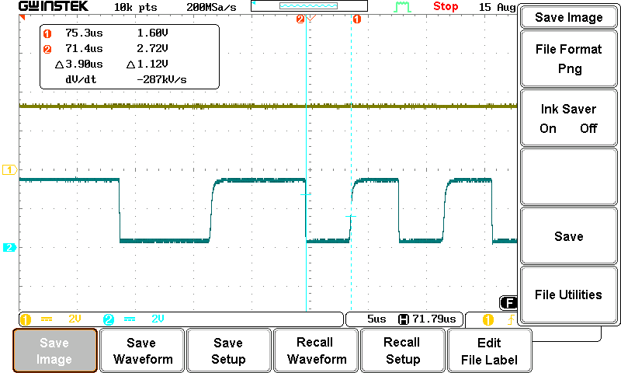

## Booster Repeater Digital Isolator Input

* Channel 1: Cutout enable (trigger)
* Channel 2: Received data

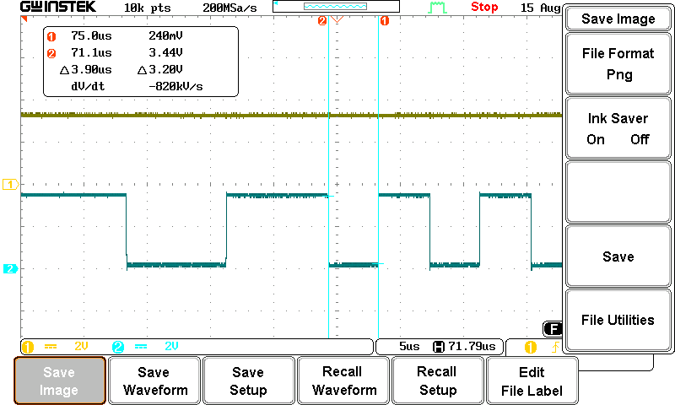

## Booster Repeater Digital Isolator Output (Repeater Transmitter)

* Channel 1: Cutout enable (trigger)
* Channel 2: Received data

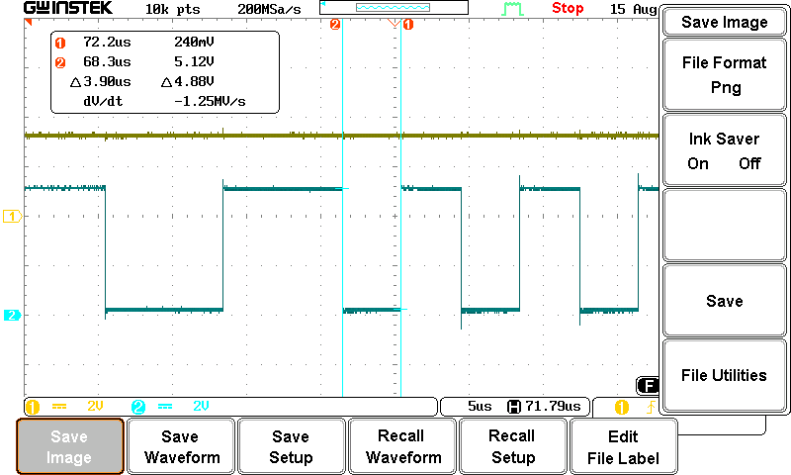

## Command Station Detector Comparator Input (1 Foot Cat5e Cable)

* Channel 1: Cutout enable (trigger)
* Channel 2: Received data

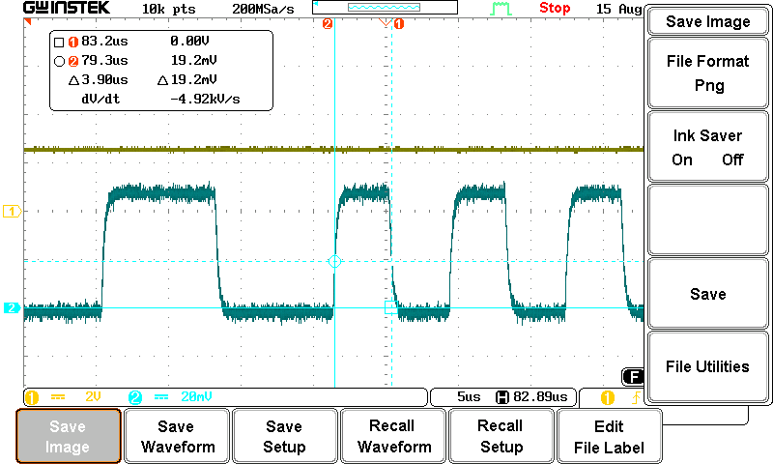

## Command Station Detector Comparator Output (1 Foot Cat5e Cable)

* Channel 1: Cutout enable (trigger)
* Channel 2: Received data

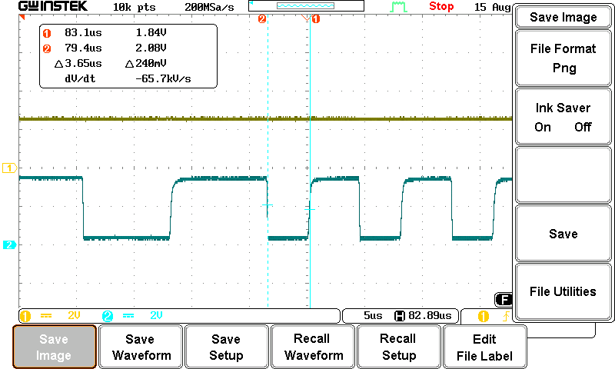

## Command Station Detector Comparator Input (1000 Feet Cat5e Cable)

* Channel 1: Cutout enable (trigger)
* Channel 2: Received data

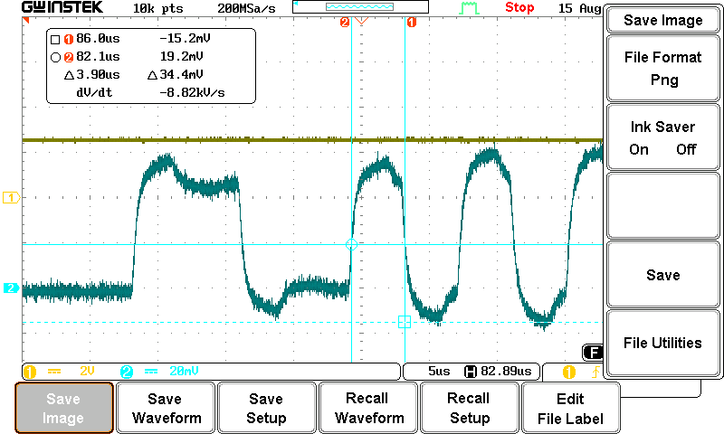

## Command Station Detector Comparator Output (1000 Feet Cat5e Cable)

* Channel 1: Cutout enable (trigger)
* Channel 2: Received data

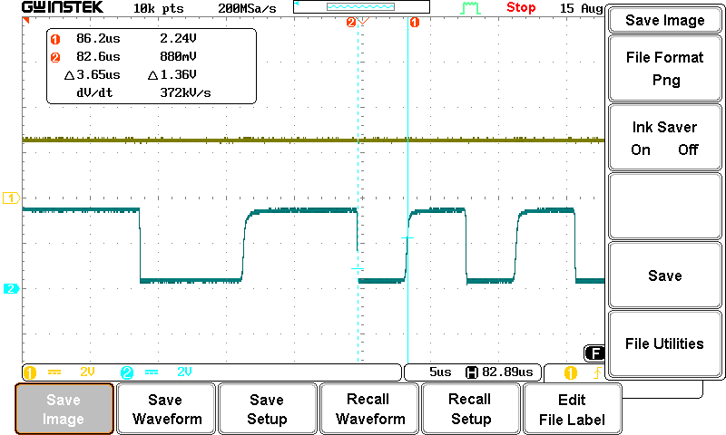

## Command Station Detector Comparator Input (1000 Feet Cat5e Cable), 6x 500Ω half rectified (simulated) booster loads at end of 1000 feet LCC Cable

* Channel 1: Cutout enable (trigger)
* Channel 2: Received data

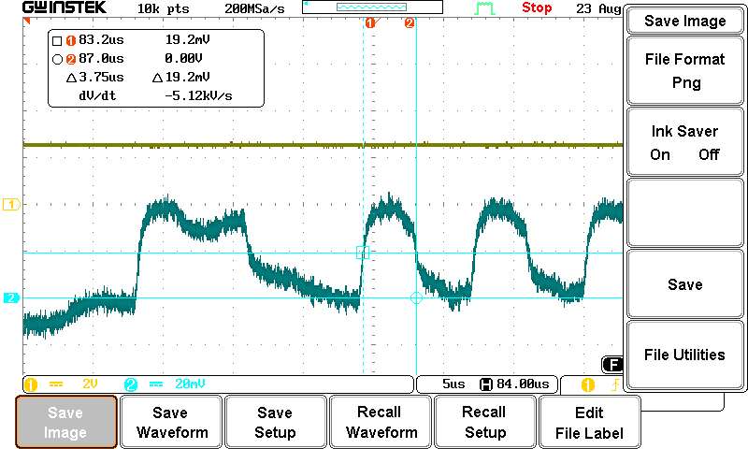

## Command Station Detector Comparator Output (1000 Feet Cat5e Cable), 6x 500Ω half rectified (simulated) booster loads at end of 1000 feet LCC Cable

* Channel 1: Cutout enable (trigger)
* Channel 2: Received data

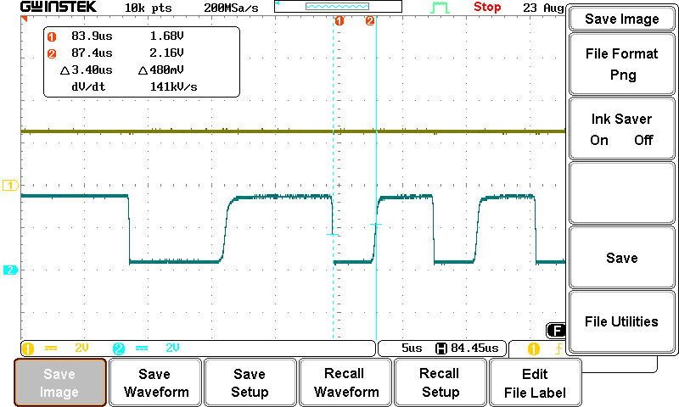

# Decoder Transmitter at Booster (<1 Foot Track Bus) With 27pF at Comparator Input

Both the Booster and Command Station detector comparator have a 27pF capacitor added.

## Booster Detector Comparator Input (Zoomed Out)

* Channel 1: Cutout enable (trigger)
* Channel 2: Received data

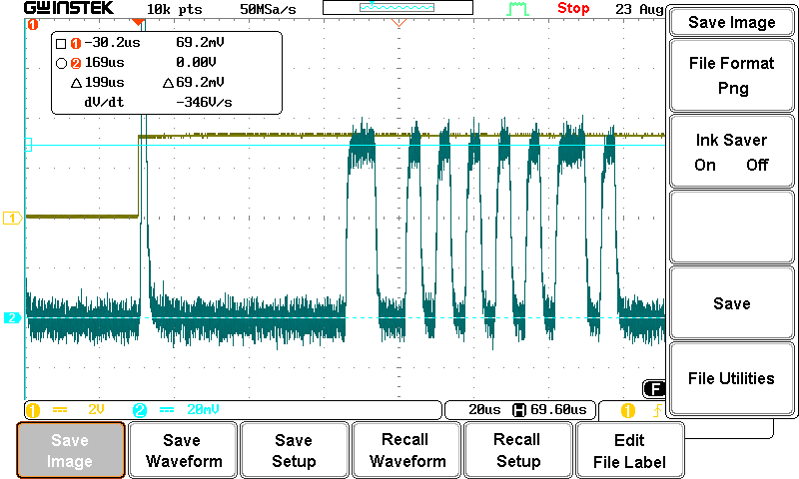

## Booster Detector Comparator Input

* Channel 1: Cutout enable (trigger)
* Channel 2: Received data

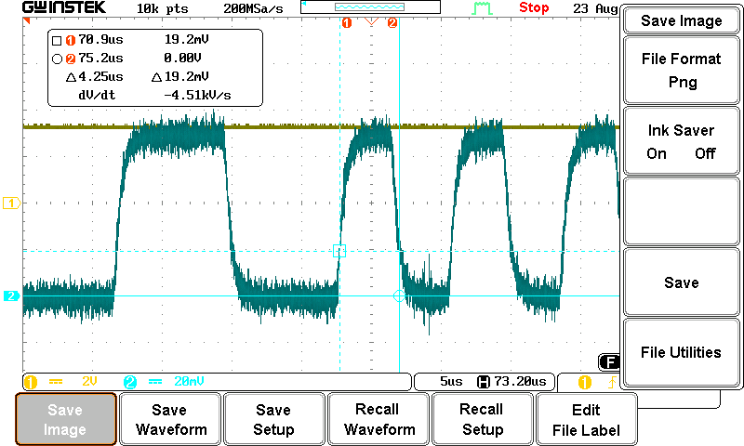

## Booster Detector Comparator Output

* Channel 1: Cutout enable (trigger)
* Channel 2: Received data

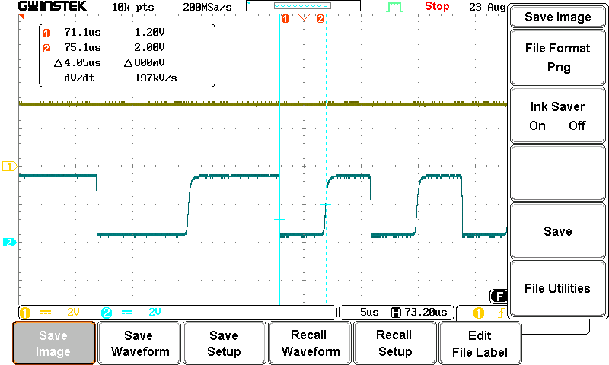

## Booster Repeater Digital Isolator Input

* Channel 1: Cutout enable (trigger)
* Channel 2: Received data

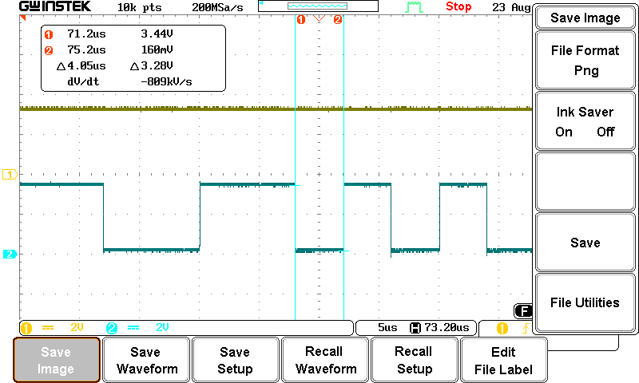

## Booster Repeater Digital Isolator Output (Repeater Transmitter)

* Channel 1: Cutout enable (trigger)
* Channel 2: Received data

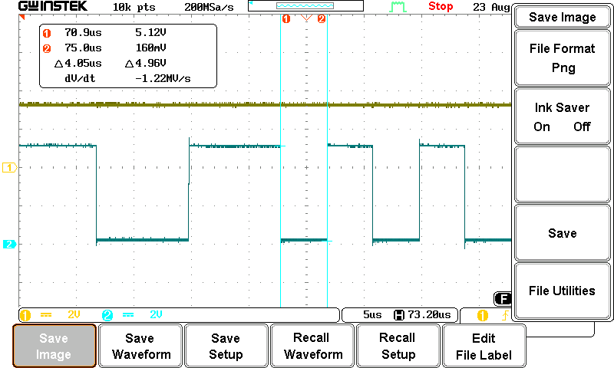

## Command Station Detector Comparator Input (1 Foot Cat5e Cable)

* Channel 1: Cutout enable (trigger)
* Channel 2: Received data

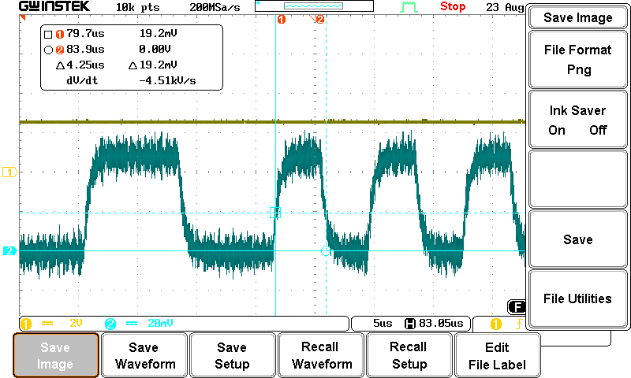

## Command Station Detector Comparator Output (1 Foot Cat5e Cable)

* Channel 1: Cutout enable (trigger)
* Channel 2: Received data

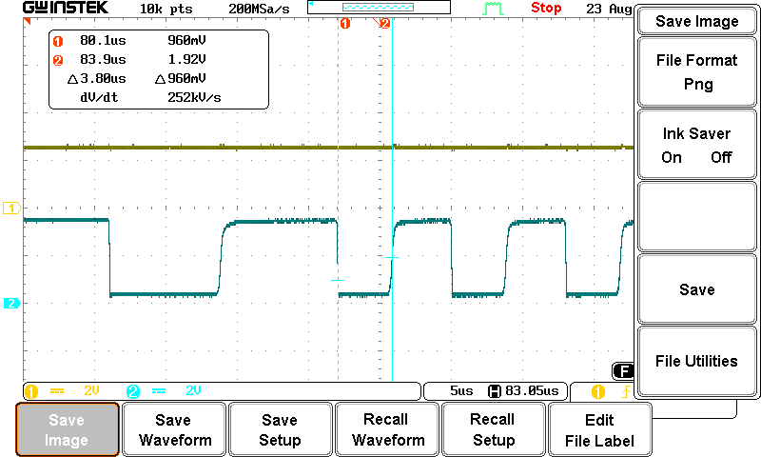

## Command Station Detector Comparator Input (1000 Foot Cat5e Cable)

* Channel 1: Cutout enable (trigger)
* Channel 2: Received data

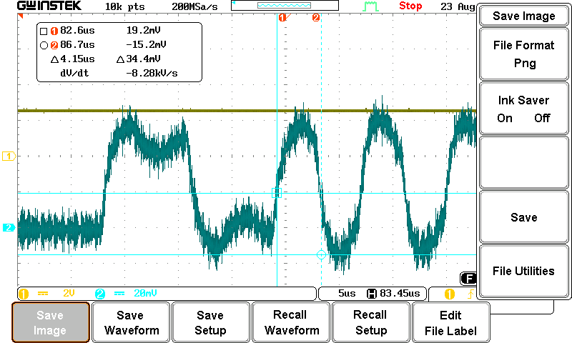

## Command Station Detector Comparator Output (1000 Foot Cat5e Cable)

* Channel 1: Cutout enable (trigger)
* Channel 2: Received data

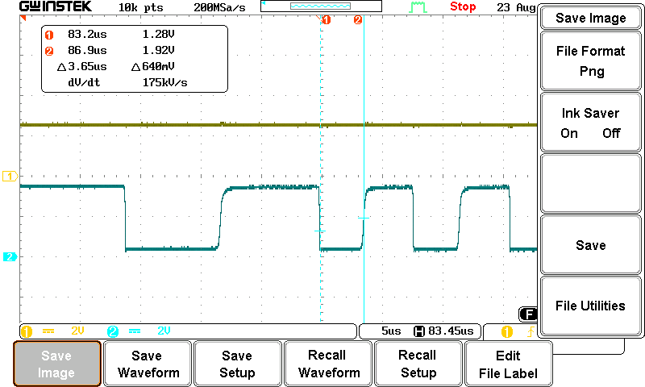

## Command Station Detector Comparator Input (242 Foot Cat5e Cable)

* Channel 1: Cutout enable (trigger)
* Channel 2: Received data

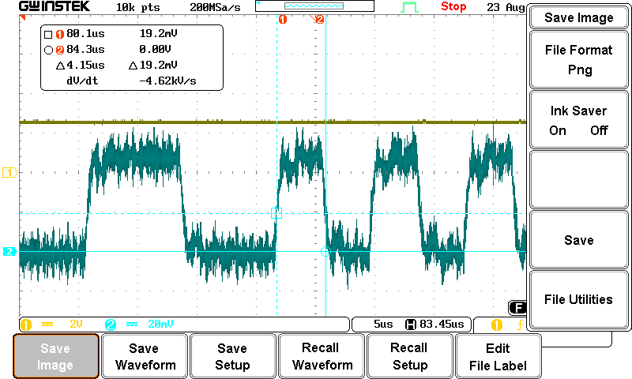

## Command Station Detector Comparator Output (242 Foot Cat5e Cable)

* Channel 1: Cutout enable (trigger)
* Channel 2: Received data

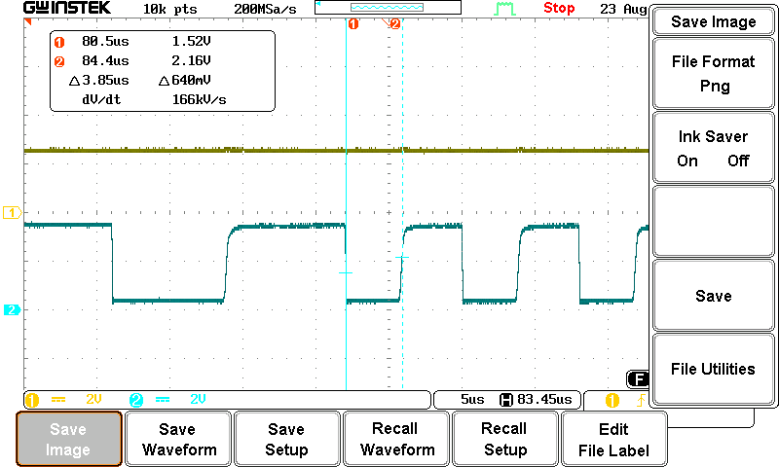

# Decoder Transmitter Placed at End of 100m Track Bus, 500Ω Half Rectified Termination

## Booster Detector Comparator Input (Zoomed Out)

* Channel 1: Cutout enable (trigger)
* Channel 2: Received data

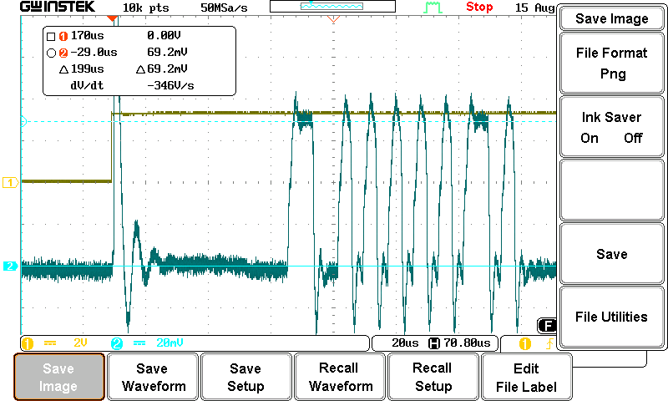

## Booster Detector Comparator Input

* Channel 1: Cutout enable (trigger)
* Channel 2: Received data

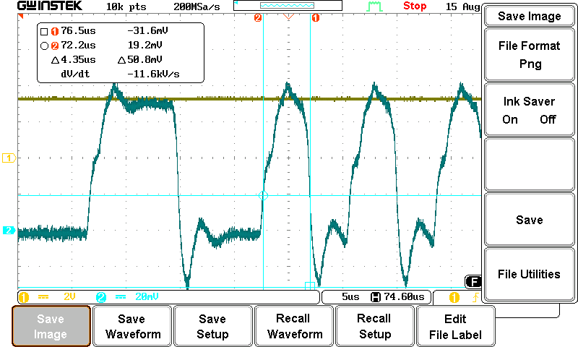

## Booster Detector Comparator Output

* Channel 1: Cutout enable (trigger)
* Channel 2: Received data

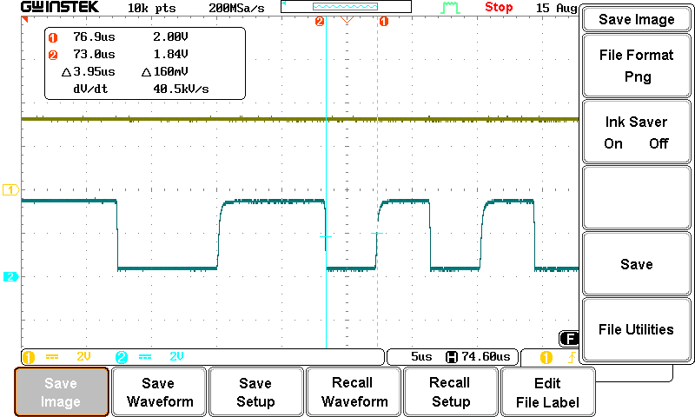

## Booster Repeater Digital Isolator Input

* Channel 1: Cutout enable (trigger)
* Channel 2: Received data

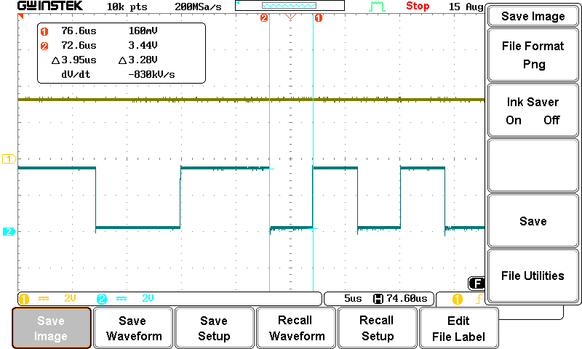

## Booster Repeater Digital Isolator Output (Repeater Transmitter)

* Channel 1: Cutout enable (trigger)
* Channel 2: Received data

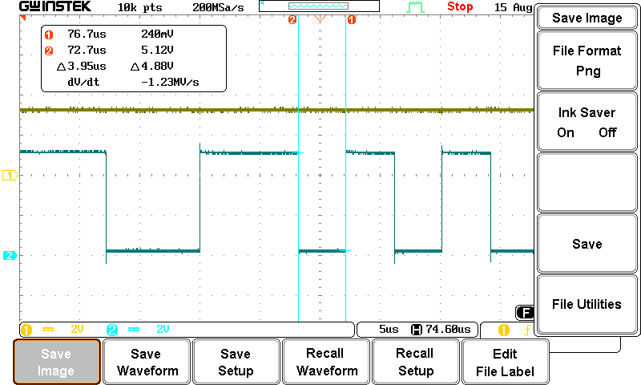

## Command Station Detector Comparator Input (1 Foot Cat5e Cable)

* Channel 1: Cutout enable (trigger)
* Channel 2: Received data

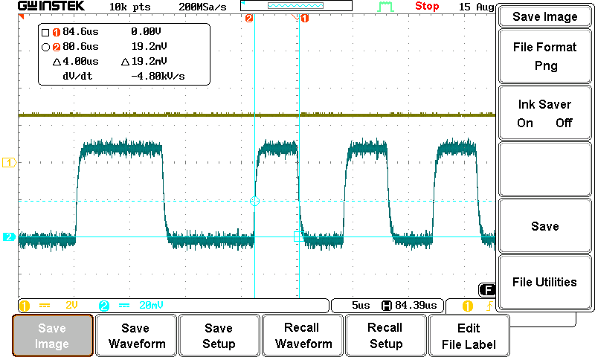

## Command Station Detector Comparator Output (1 Foot Cat5e Cable)

* Channel 1: Cutout enable (trigger)
* Channel 2: Received data

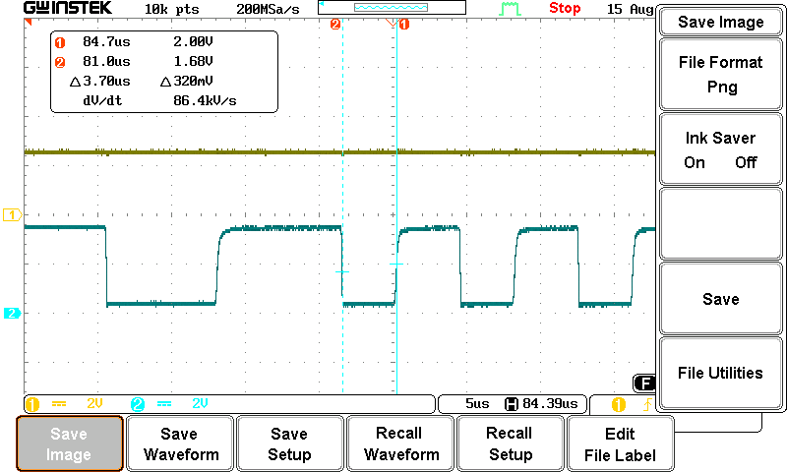

## Command Station Detector Comparator Input (1000 Foot Cat5e Cable)

* Channel 1: Cutout enable (trigger)
* Channel 2: Received data

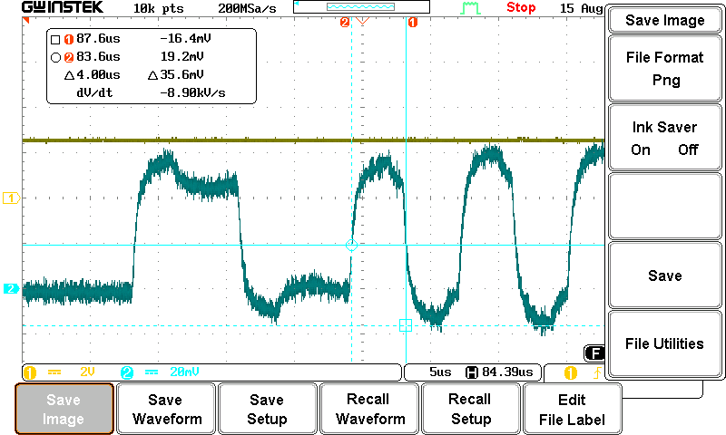

## Command Station Detector Comparator Output (1000 Foot Cat5e Cable)

* Channel 1: Cutout enable (trigger)
* Channel 2: Received data

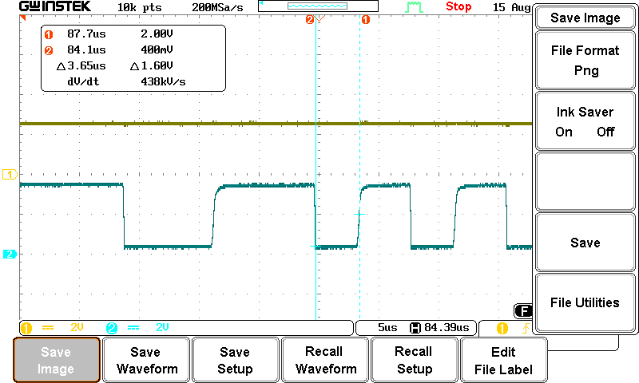

## Command Station Detector Comparator Input (242 Foot Cat5e Cable)

* Channel 1: Cutout enable (trigger)
* Channel 2: Received data

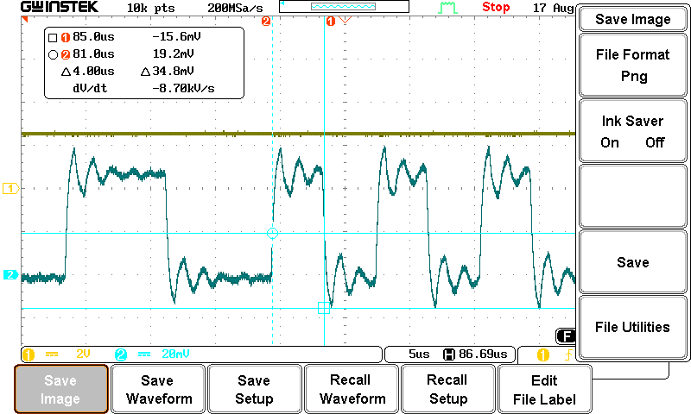

## Command Station Detector Comparator Output (242 Foot Cat5e Cable)

* Channel 1: Cutout enable (trigger)
* Channel 2: Received data

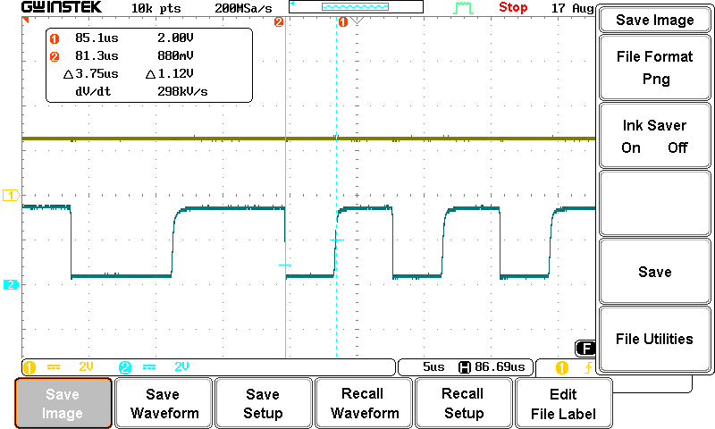

## Track Voltage at Decoder Transmitter during Data Transmission

* Channel 1: Transmit data (MCU UART Pin)
* Channel 2: Transmit data (Track Voltage)

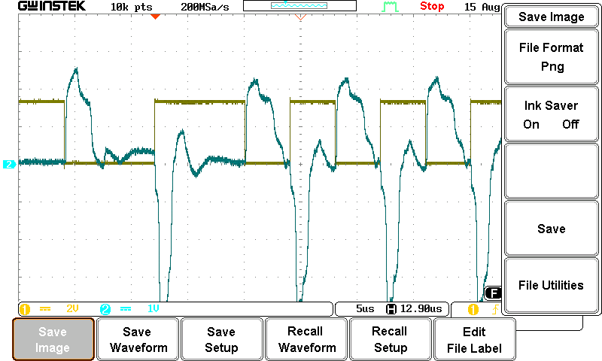

# Decoder Transmitter at End of 100m Track Bus, 500Ω Half Rectified Termination With 27pF at Comparator Input

Both the Booster and Command Station detector comparator have a 27pF capacitor added.

## Booster Detector Comparator Input (Zoomed Out)

* Channel 1: Cutout enable (trigger)
* Channel 2: Received data

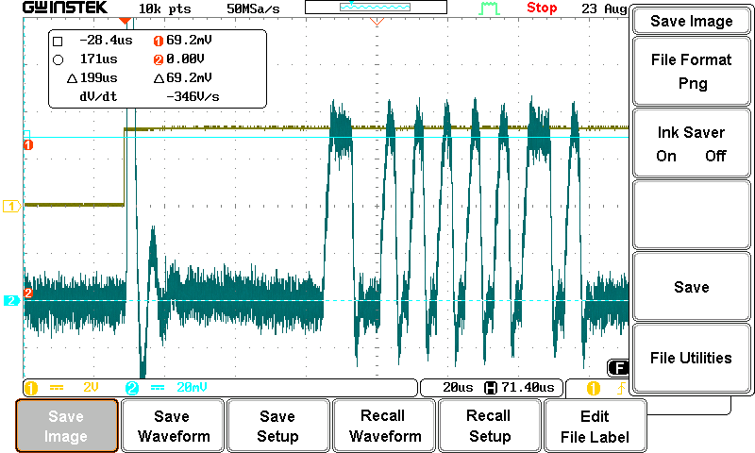

## Booster Detector Comparator Input

* Channel 1: Cutout enable (trigger)
* Channel 2: Received data

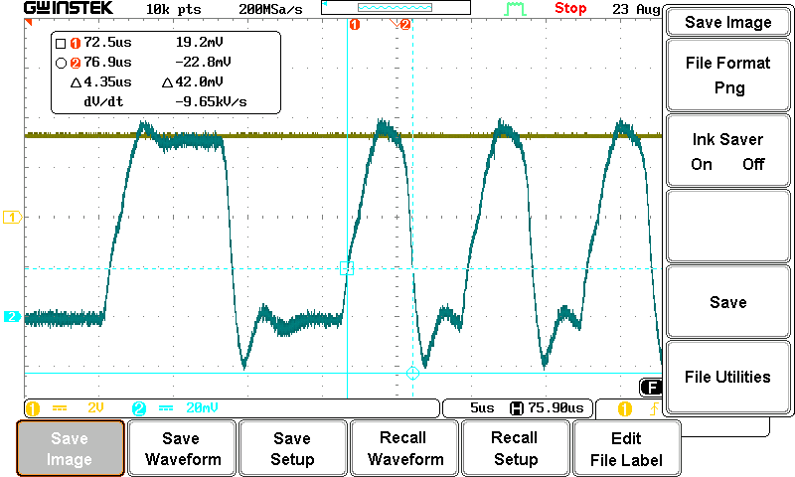

## Booster Detector Comparator Output

* Channel 1: Cutout enable (trigger)
* Channel 2: Received data

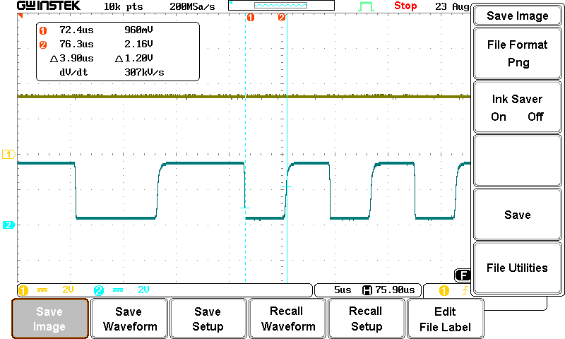

## Booster Repeater Digital Isolator Input

* Channel 1: Cutout enable (trigger)
* Channel 2: Received data

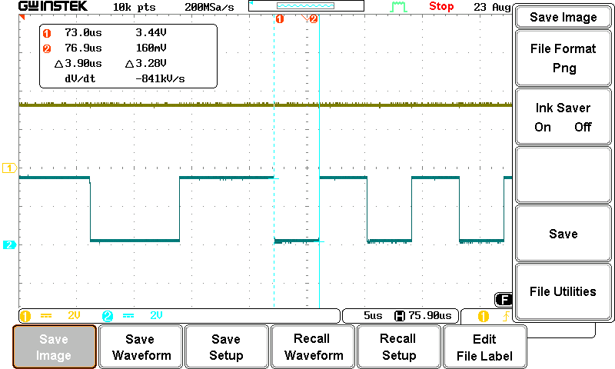

## Booster Repeater Digital Isolator Output (Repeater Transmitter)

* Channel 1: Cutout enable (trigger)
* Channel 2: Received data

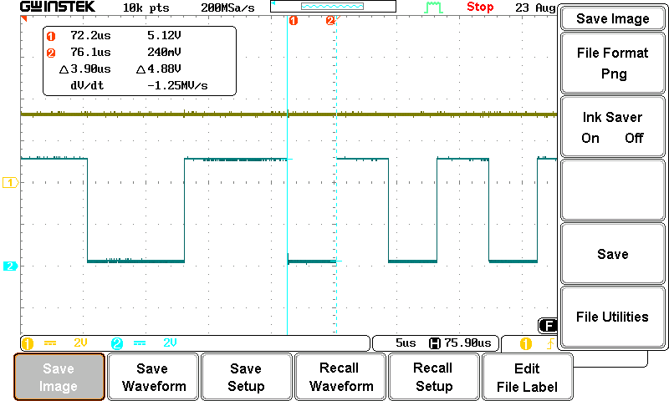

## Command Station Detector Comparator Input (1 Foot Cat5e Cable)

* Channel 1: Cutout enable (trigger)
* Channel 2: Received data

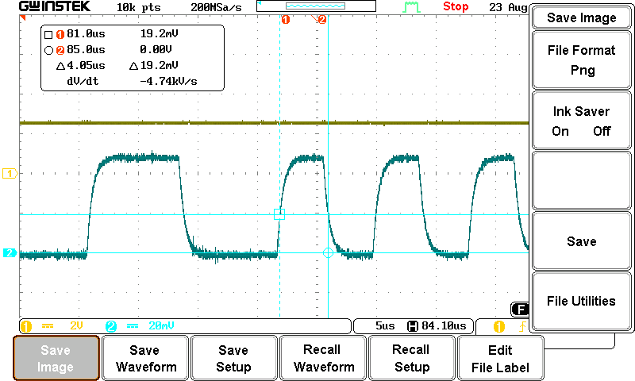

## Command Station Detector Comparator Output (1 Foot Cat5e Cable)

* Channel 1: Cutout enable (trigger)
* Channel 2: Received data

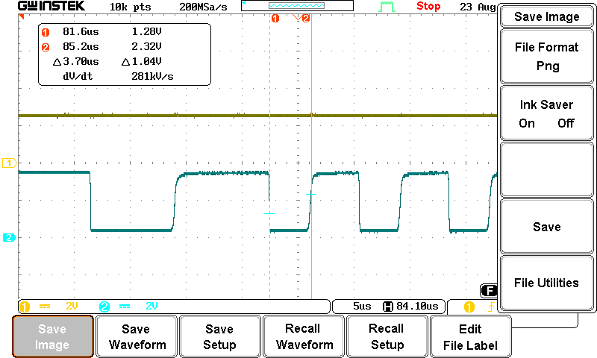

## Command Station Detector Comparator Input (1000 Foot Cat5e Cable)

* Channel 1: Cutout enable (trigger)
* Channel 2: Received data

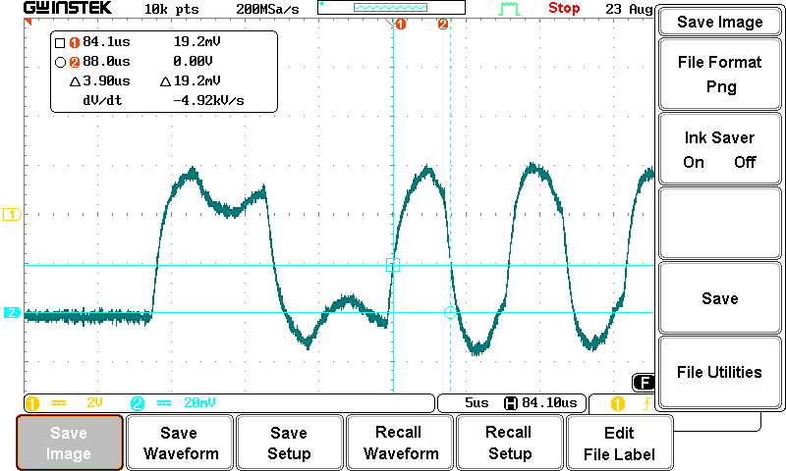

## Command Station Detector Comparator Output (1000 Foot Cat5e Cable)

* Channel 1: Cutout enable (trigger)
* Channel 2: Received data

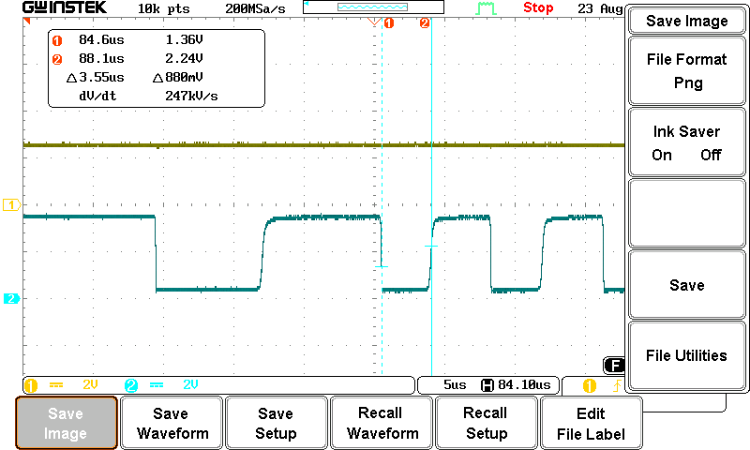

## Command Station Detector Comparator Input (242 Foot Cat5e Cable)

* Channel 1: Cutout enable (trigger)
* Channel 2: Received data

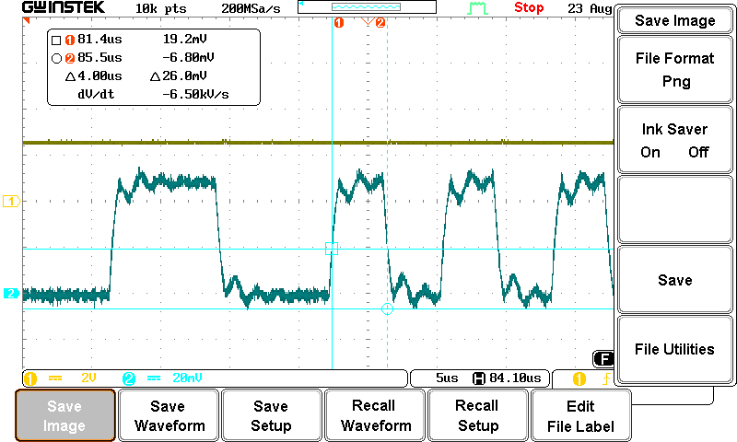

## Command Station Detector Comparator Output (242 Foot Cat5e Cable)

* Channel 1: Cutout enable (trigger)
* Channel 2: Received data

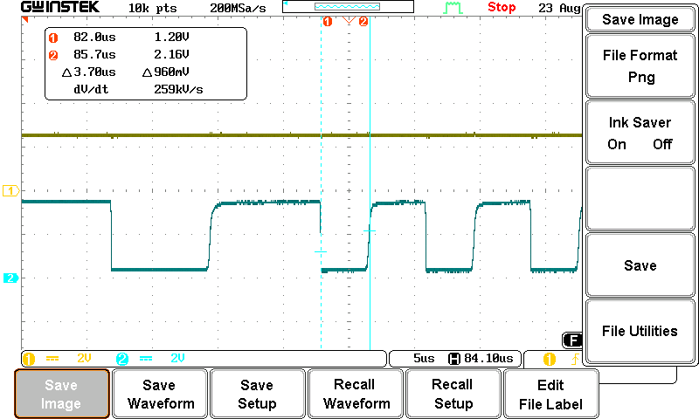

# Decoder Transmitter Placed at End of 100m Track Bus, No Termination

## Booster Detector Comparator Input (Zoomed Out)

* Channel 1: Cutout enable (trigger)
* Channel 2: Received data

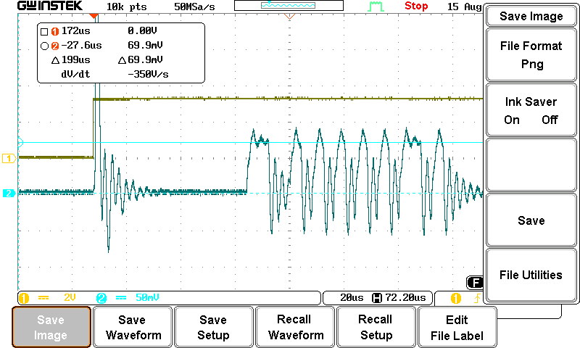

## Booster Detector Comparator Input

* Channel 1: Cutout enable (trigger)
* Channel 2: Received data

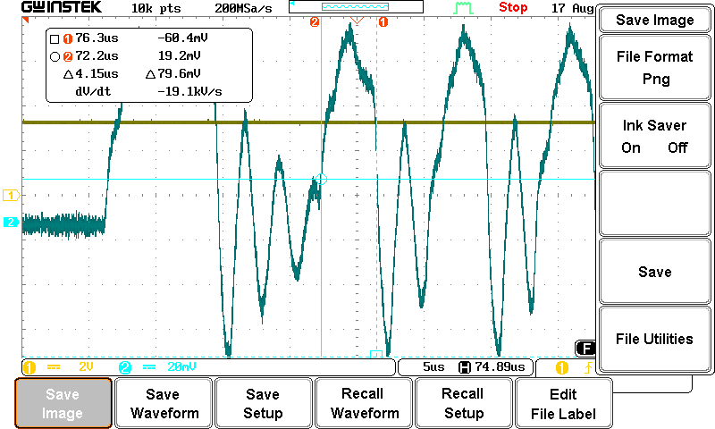

## Booster Detector Comparator Output

* Channel 1: Cutout enable (trigger)
* Channel 2: Received data

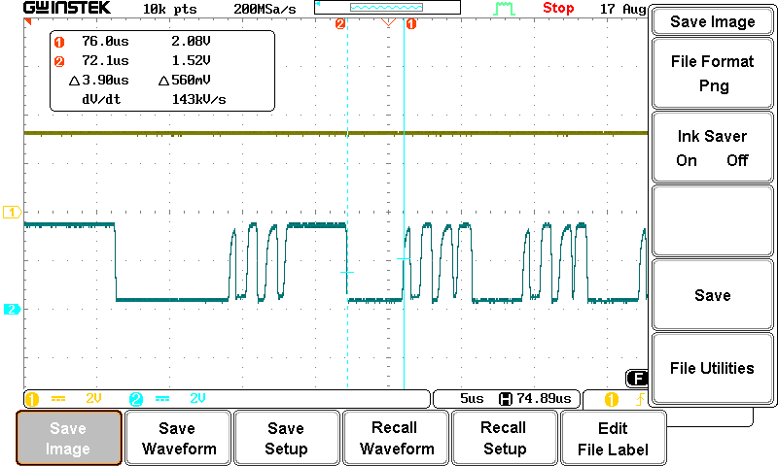

## Booster Digital Isolator Input

* Channel 1: Cutout enable (trigger)
* Channel 2: Received data

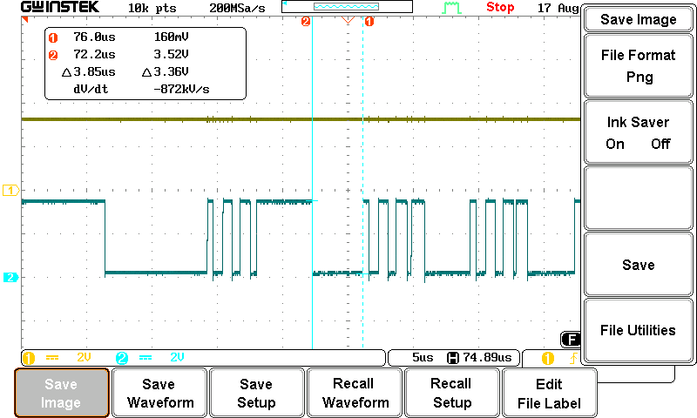

## Booster Digital Isolator Output (Repeater Transmitter)

* Channel 1: Cutout enable (trigger)
* Channel 2: Received data

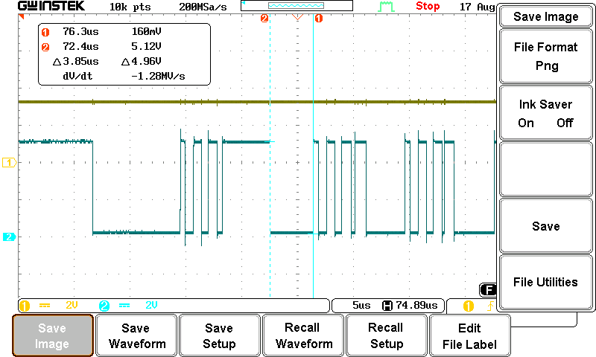

## Command Station Detector Comparator Input (1 Foot Cat5e Cable)

* Channel 1: Cutout enable (trigger)
* Channel 2: Received data

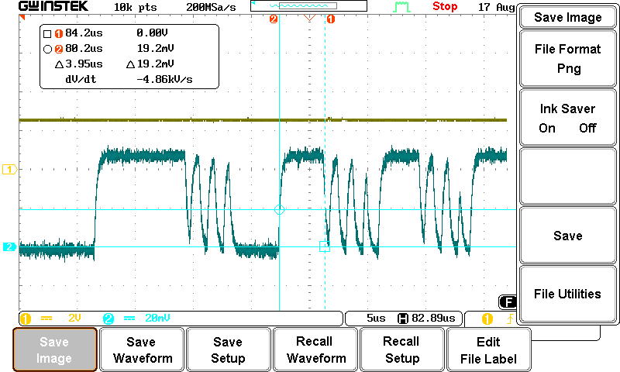

## Command Station Detector Comparator Output (1 Foot Cat5e Cable)

* Channel 1: Cutout enable (trigger)
* Channel 2: Received data

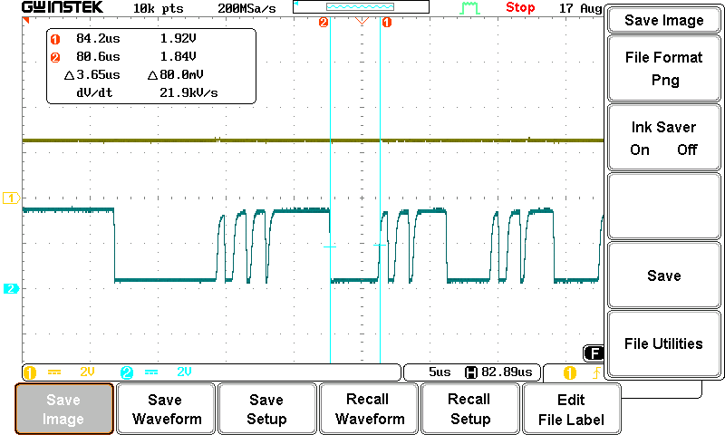

## Command Station Detector Comparator Input (1000 Foot Cat5e Cable)

* Channel 1: Cutout enable (trigger)
* Channel 2: Received data

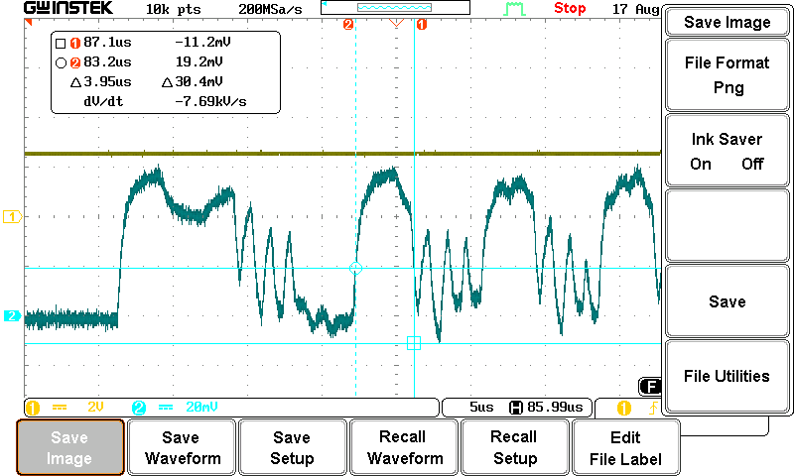

## Command Station Detector Comparator Output (1000 Foot Cat5e Cable)

* Channel 1: Cutout enable (trigger)
* Channel 2: Received data

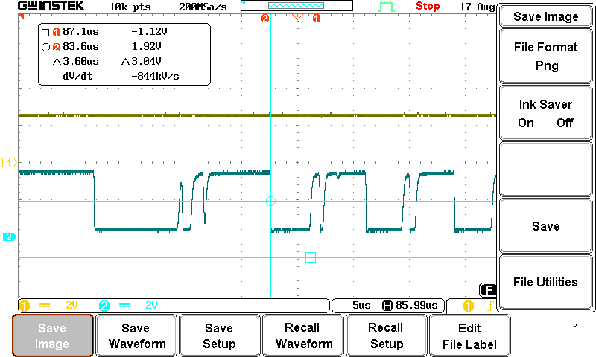

## Track Voltage at Decoder Transmitter during Data Transmission

* Channel 1: Transmit data (MCU UART Pin)
* Channel 2: Transmit data (Track Voltage)

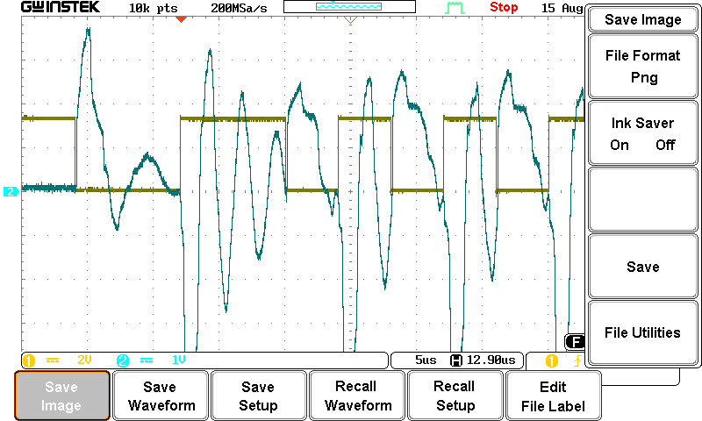

# Decoder Transmitter Placed at End of 100m Track Bus, 110Ω Termination

## Booster Detector Comparator Input (Zoomed Out)

* Channel 1: Cutout enable (trigger)
* Channel 2: Received data

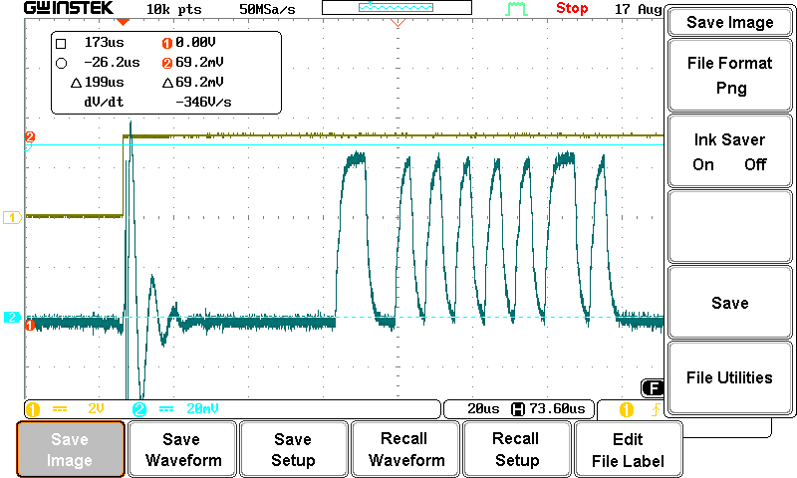

## Booster Detector Comparator Input

* Channel 1: Cutout enable (trigger)
* Channel 2: Received data

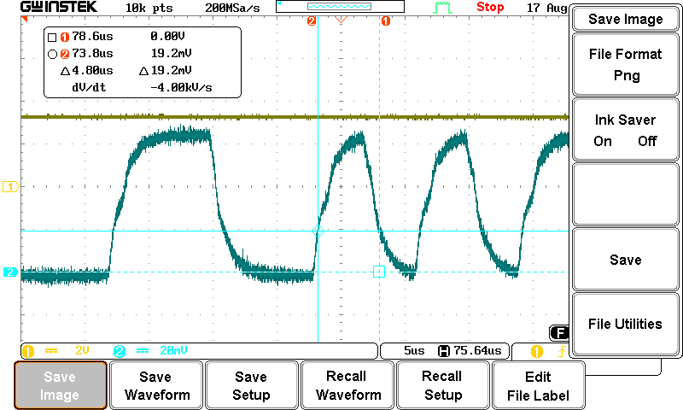

## Booster Detector Comparator Output

* Channel 1: Cutout enable (trigger)
* Channel 2: Received data

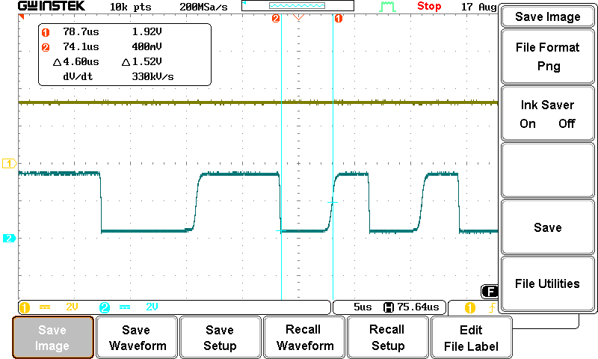

## Booster Digital Isolator Input

* Channel 1: Cutout enable (trigger)
* Channel 2: Received data

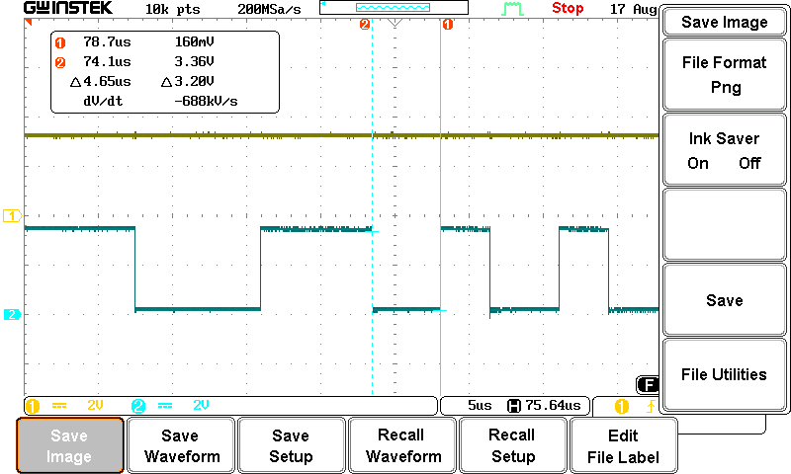

# Booster Repeater Transmitter Voltage

## Voltage at Booster Transmitter Output (Power Station Interface), 1000 Feed of Cat5e between Booster and Command Station

* Channel 1: Transmitter digital data
* Channel 2: Transmitter voltage data

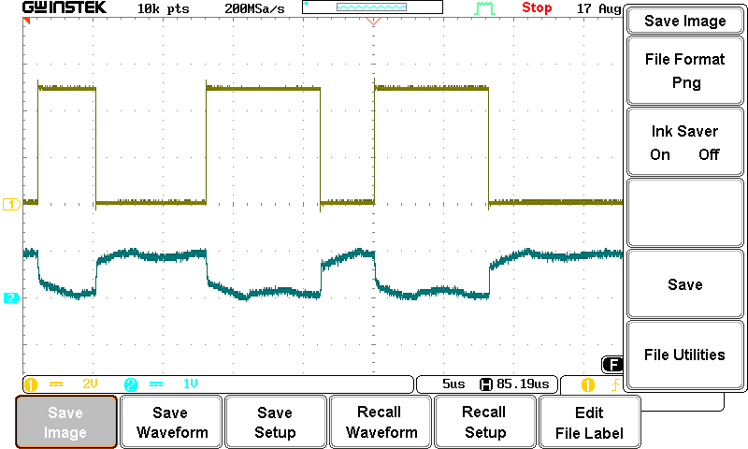

# Transmitter Current at End of 100m Track Bus

Measured at end of 100m track bus (at decoder transmitter).

## No Termination

* Channel 1: Transmitter digital data
* Channel 2: Track current, current probe, 4mV == 1mA
* Channel 3: Track voltage, differential probe, 2V/div

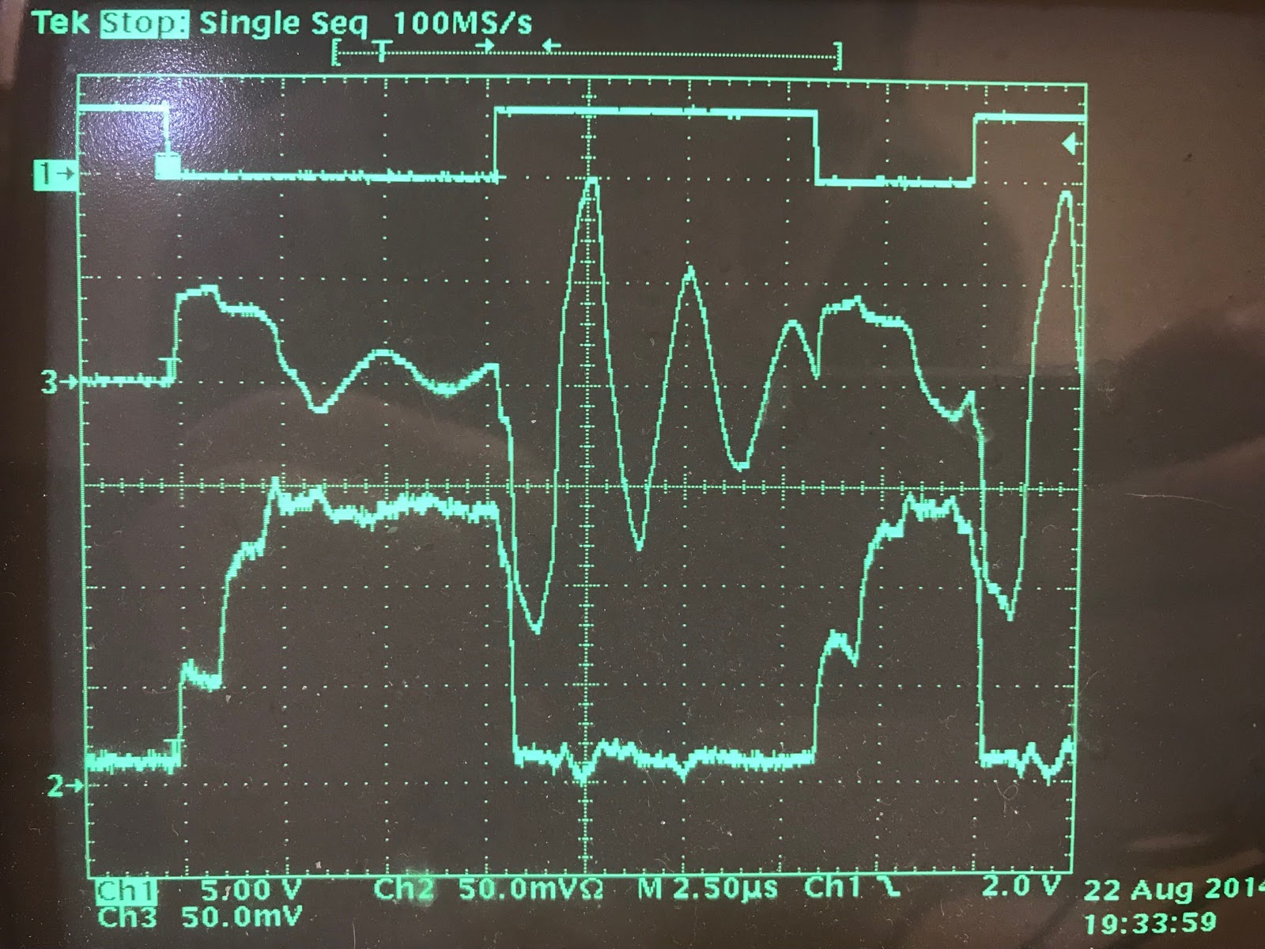

## 500Ω Half Rectified Termination

* Channel 1: Transmitter digital data
* Channel 2: Track current, current probe, 4mV == 1mA
* Channel 3: Track voltage, differential probe, 2V/div

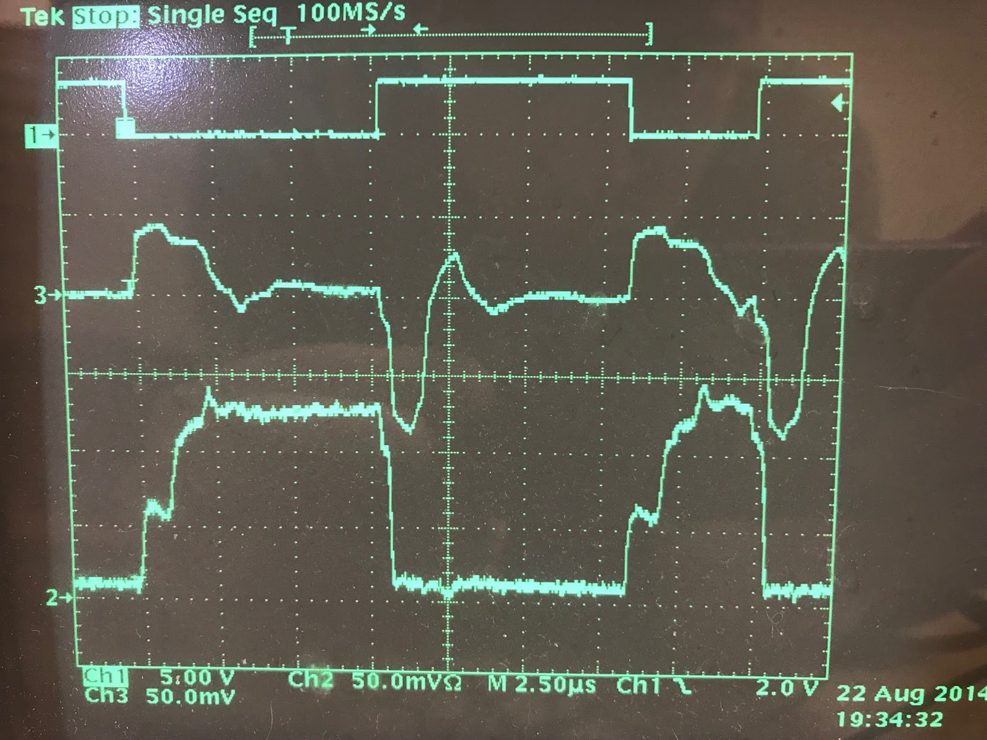

# Document History

|  |  |
| --- | --- |
| **Date** | **Description** |
|  | First Revision |
|  |  |
|  |  |
|  |  |

**Important Notices and Disclaimers Concerning NMRA Standards Documents**

The Standards (S), Recommended Practices (RP), Technical Note (TN), and Technical Information (TI) documents of the National Model Railroad Association (“NMRA Standards documents”) are made available for use subject to important notices and legal disclaimers. These notices and disclaimers, or a reference to this page, appear in all standards and may be found under the heading "Important Notices and Disclaimers Concerning NMRA Standards Documents."

**Notice and Disclaimer of Liability Concerning the Use of NMRA Standards Documents**

NMRA Standards documents are developed within the Standards and Conformance Department of the NMRA in association with certain Working Groups, members, and representatives of manufacturers and sellers. NMRA develops its standards through a consensus development process, which brings together volunteers representing varied viewpoints and interests to achieve the final product. NMRA Standards documents are developed by volunteers with modeling, railroading, engineering, and industry-based expertise. Volunteers are not necessarily members of NMRA, and participate without compensation from NMRA.

NMRA does not warrant or represent the accuracy or completeness of the material contained in NMRA Standards documents, and expressly disclaims all warranties (express, implied and statutory) not included in this or any other document relating to the standard or recommended practice, including, but not limited to, the warranties of: merchantability; fitness for a particular purpose; non-infringement; and quality, accuracy, effectiveness, currency, or completeness of material. In addition, NMRA disclaims any and all conditions relating to results and workmanlike effort. In addition, NMRA does not warrant or represent that the use of the material contained in NMRA Standards documents is free from patent infringement. NMRA Standards documents are supplied “AS IS” and “WITH ALL FAULTS.”

Use of NMRA Standards documents is wholly voluntary. The existence of an NMRA Standard or Recommended Practice does not imply that there are no other ways to produce, test, measure, purchase, market, or provide other goods and services related to the scope of the NMRA Standards documents. Furthermore, the viewpoint expressed at the time that NMRA approves or issues a Standard or Recommended Practice is subject to change brought about through developments in the state of the art and comments received from users of NMRA Standards documents.

In publishing and making its standards available, NMRA is not suggesting or rendering professional or other services for, or on behalf of, any person or entity, nor is NMRA undertaking to perform any duty owed by any other person or entity to another. Any person utilizing any NMRA Standards document, should rely upon their own independent judgment in the exercise of reasonable care in any given circumstances or, as appropriate, seek the advice of a competent professional in determining the appropriateness of a given NMRA Standards documents.

IN NO EVENT SHALL NMRA BE LIABLE FOR ANY DIRECT, INDIRECT, INCIDENTAL, SPECIAL, EXEMPLARY, OR CONSEQUENTIAL DAMAGES (INCLUDING, BUT NOT LIMITED TO: THE NEED TO PROCURE SUBSTITUTE GOODS OR SERVICES; LOSS OF USE, DATA, OR PROFITS; OR BUSINESS INTERRUPTION) HOWEVER CAUSED AND ON ANY THEORY OF LIABILITY, WHETHER IN CONTRACT, STRICT LIABILITY, OR TORT (INCLUDING NEGLIGENCE OR OTHERWISE) ARISING IN ANY WAY OUT OF THE PUBLICATION, USE OF, OR RELIANCE UPON ANY STANDARD OR RECOMMENDED PRACTICE, EVEN IF ADVISED OF THE POSSIBILITY OF SUCH DAMAGE AND REGARDLESS OF WHETHER SUCH DAMAGE WAS FORESEEABLE.

**Translations**

NMRA’s development of NMRA Standards documents involves the review of documents in English only. In the event that an NMRA Standards document is translated, only the English version published by NMRA is the approved NMRA Standards document.

**Official Statements**

A statement, written or oral, that is not processed in accordance with NMRA policies for distribution of NMRA communications, or approved by the Board of Directors, an officer or committee chairperson, shall not be considered or inferred to be the official position of NMRA or any of its committees and shall not be considered to be, nor be relied upon as, a formal position of NMRA.

**Comments on Standards**

Comments for revision of NMRA Standards documents are welcome from any interested party, regardless of membership. However, **NMRA does not provide interpretations, consulting information, or advice pertaining to NMRA Standards documents.**

Suggestions for changes in documents should be in the form of a proposed change of text, together with appropriate supporting comments. Since NMRA standards represent a consensus of concerned interests, it is important that any responses to comments and questions also receive the concurrence of a balance of interests. For this reason, NMRA, its departments, Working Groups or committees cannot provide an instant response to comments, or questions except in those cases where the matter has previously been addressed. For the same reason, NMRA does not respond to interpretation requests. Any person who would like to participate in evaluating comments or in revisions to NMRA Standards documents may request participation in the relevant NMRA working group.

**Laws & Regulations**

Users of NMRA Standards documents should consult all applicable laws and regulations. Compliance with the provisions of any NMRA Standards document does not constitute compliance to any applicable regulatory requirements. Implementers of the standard are responsible for observing or referring to the applicable regulatory requirements. NMRA does not, by the publication of NMRA Standards documents, intend to urge action that is not in compliance with applicable laws, and NMRA Standards documents may not be construed as doing so.

**Copyrights**

NMRA Standards documents are copyrighted by NMRA under US and international copyright laws. They are made available by NMRA and are adopted for a wide variety of both public and private uses. These include both use, by reference, in laws and regulations, and use in private self-regulation, standardization, and the promotion of modeling, structural and engineering practices and methods. By making NMRA Standards documents available for use and adoption by public authorities and private users, NMRA does not waive any rights in copyright to the NMRA Standards documents.

**IMPORTANT NOTICE**

NMRA Standards documents do not guarantee or ensure safety, security, health, or environmental protection, or ensure against interference with or from other systems, devices or networks. NMRA Standards documents development activities consider research and information presented to the standards development group in developing any safety recommendations. Other information about safety practices, changes in technology or technology implementation, or impact by peripheral systems also may be pertinent to safety considerations during implementation of the standard. Implementers and users of NMRA Standards documents are responsible for determining and complying with all appropriate safety, security, environmental, health, and interference protection practices and all applicable laws and regulations.